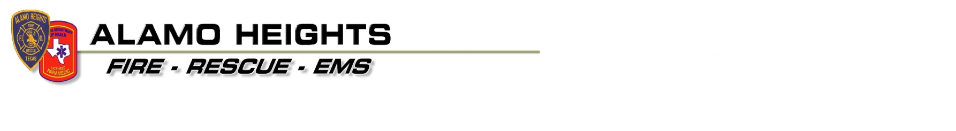

Fire / Safety Concern | Yes | No | Corrective actions
Address/Unit # clearly visible from street
FD access to all sides of the structure
Electrical Service line clear of obstructions
Gas meter visible
Water meter visible
Smoke/CO detectors installed per Manufacturers specifications
Smoke/CO detector batteries marked with date of installation
Smoke/CO detector batteries changed at “Time Change”
E.D.I.T.H. in place and practiced (emergency exit drill)
All windows and doors will open from the inside
Proper fire extinguisher present
Heat sources / stove burners are clear of combustible materials
Oven/ Stove clean of debris
Resident reminded to not leave cooking foods unattended
Water heater temperature does not exceed 120 degrees
Light bulbs do not exceed maximum wattage recommendations
Cabinets secured with child-proof latch device
Portable space heaters at least 3 feet from combustible materials
Electrical panel inspected for hazards (tape, missing breakers)
Electrical panel circuits labeled
Proper use of extension cords
Poisons/insecticides stored properly
Outdoor cooking area clear of hazards
Outdoor cooking materials disposed of properly
Smoking materials disposed of properly
Matches/lighters stored safely
Swimming pool/Spa area secured/gated
Pool/Spa chemicals stored properly
Screen in place in front of fireplace
HVAC / Furnace inspected/ cleaned annually
HVAC / Furnace filters changed per manufacturers specifications
Clothes dryer lint trap cleaned/inspected
Dryer vent hose properly functioning and intact
Gasoline stored in approved safety cans
Flammable/combustible liquids stored away from heat sources
Fire Dept notified of any special-needs residents
Area rugs have non-slip backing
Egress ladders in place for two story homes
Chimney inspected/cleaned annually by certified personnel
Water heater in garage min. 18” from floor
Other:
Other:

Contact Name |  | Date
Address |  | Start Time
Telephone # |  | Complete Time
FD Personnel
Residential Fire Safety Home Checklist

The Residential Fire & Safety Program checklist is available at no cost. The checklist covers a variety of potential hazards that may occur, but does not cover every hazard that may be experienced. The completion of the Residential Fire & Safety Checklist does not guarantee that a hazard will not occur. By requesting a copy of the Residential Fire & Safety Checklist it is understood that the homeowner will not hold the Alamo Heights Fire Dept responsible for any future hazards or emergencies that may occur in the residence.

Printed Name:________________________________________

Signature:______________________________E-mail:___________________________________

